The Capital city of [Uttar Pradesh](https://www.transindiatravels.com/uttar-pradesh/tourist-places-to-visit-in-uttar-pradesh/)[[1]](#endnote-1) and often described as the ‘*City of Nawabs*’, Lucknow is one of the most [[2]](#footnote-1)pristine and multicultural tourist destinations of India. The city primarily flourished during the 18th and the 19th centuries as an artistic and cultural center of India under the reign of the Nawabs of Awadh. The city is also the second largest city of North India and the 11th largest city in the country. The city *contains*

***contains***, 1

second largest, 1

Contents

[**1. Bara Imambara** 2](#_Toc165659654)

[**2. Chota Imambara** 3](#_Toc165659655)

[**3. British Residency** 4](#_Toc165659656)

[**4. Lucknow Zoo** 5](#_Toc165659657)

[**5. Hazratganj** 6](#_Toc165659658)

[**6. Constantia House** 7](#_Toc165659659)

[**7. Dr. Ambedkar Park** 8](#_Toc165659660)

[**8. Lucknow Museum** 9](#_Toc165659661)

[**9. Rumi Darwaza** 10](#_Toc165659662)

[**10. Chattar Manzil** 11](#_Toc165659663)

[**11. Begum Hazrat Mahal Park** 12](#_Toc165659664)

[**About Rohit** 13](#_Toc165659665)

[4 thoughts on “Best 11 Places To Visit In Lucknow” 14](#_Toc165659666)

(vipul, 2012)Cases

(vipul, 2012) 2

# Bibliography

vipul. (2012). *yrer.* lkp: ariafr.

various architectural wonders, historical monuments, cuisines and is a cultural hub in itself. Here’s the list of **best places you must visit in Lucknow**.

**Contents**[[show](https://www.transindiatravels.com/uttar-pradesh/lucknow/tourist-places-visit-lucknow/)]

**1. Bara Imambara**

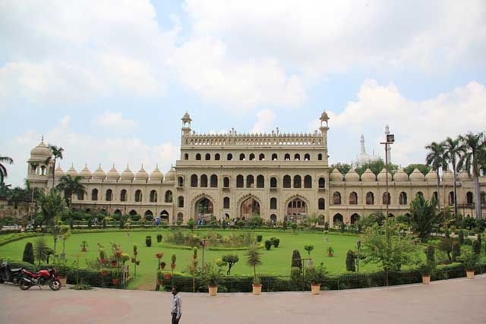[*Photo*](https://www.flickr.com/photos/adeelanwer/9696386352)*by Adeel Anwer,*[*CC BY-ND 2.0*](https://creativecommons.org/licenses/by-nd/2.0/)

The name refers to a shrine built by the Nawab Asaf-ud-daula in 1784, and is one of the largest buildings in Lucknow. The name **‘Bara Imambara**’ is an Urdu word, wherein the word ‘Bara’ means big and ‘Imambara’ means the shrine complex. The complex includes the Asfi mosque and the Bhulbhulaiya or the Labyrinth. The Asfi mosque contains the tomb of Asaf-ud-daula, and the labyrinth is the only maze in India and supports the massive structure of the whole complex from the underground.

**2. Chota Imambara**

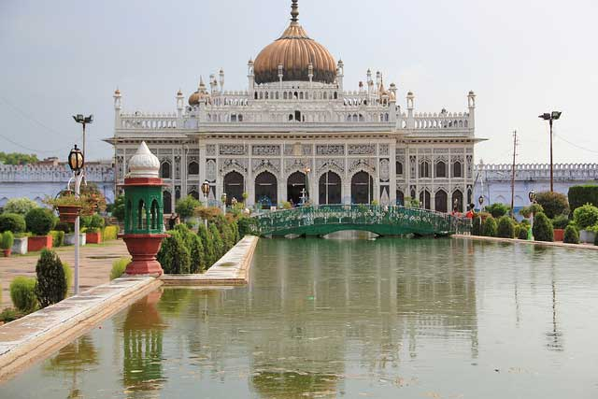*[Photo](https://www.flickr.com/photos/adeelanwer/9693221675" \t "_blank) by Adeel Anwer, [CC BY-ND 2.0](https://creativecommons.org/licenses/by-nd/2.0/" \t "_blank)*

Another congregation complex of the Shia Muslim sect, The **Chota Imambara** was built in 1838 by Nawab Muhammad Shah Ali. The complex also serves as the tomb for the Nawab who is buried there alongside his mother. Right outside the complex also lays the 4 storied Satkhanda, an unfinished watchtower or observatory which was supposed to have 7 stories. The Nawab wanted to make a tower as tall as the Qutab Minar and is like the Leaning Tower of Pisa in design.

**3. British Residency**

*[Photo](https://www.flickr.com/photos/ajay_g/8444661412" \t "_blank) by BOMBMAN, [CC BY 2.0](https://creativecommons.org/licenses/by/2.0/" \t "_blank)*

**British Residency** is regarded as a National Monument and is one of the major sites of the Revolt of 1857 and the historic battle known as the Seige of Lucknow. The site was the residence of the British Resident General which was stormed during the battle. The structure though in ruins after the battle has still been preserved till date with the bullet grazed walls and is surrounded by gardens which attract a great number of tourist crowd.

**4. Lucknow Zoo**

*[Photo](https://www.flickr.com/photos/adeelanwer/9644863463" \t "_blank) by Adeel Anwer, [CC BY-ND 2.0](https://creativecommons.org/licenses/by-nd/2.0/" \t "_blank)*

**Lucknow Zoo** is also known as The Prince of Wales Zoological Park and is spread across an area of 71.6 acres of land. The zoo was built in 1921 to welcome the arrival of the Prince of Wales and contains several species of birds, animals and reptiles. The zoo is famous for breeding and housing endangered species like the White Tiger, Indian Wolf and Hog Deer etc.

**5. Hazratganj**

*[Photo](https://www.flickr.com/photos/adeelanwer/9645188823" \t "_blank) by Adeel Anwer, [CC BY-ND 2.0](https://creativecommons.org/licenses/by-nd/2.0/" \t "_blank)*

Want to go on a shopping spree? **Hazratganj** is the answer for you. The traditional Indian bazaars of Hazratganj contains several shops that sell items ranging from jewelry, handicrafts, handloom, electronics, automobiles and contains various shopping malls, restaurants, movie theaters and a library.

**6. Constantia House**

*[Photo](https://www.flickr.com/photos/ajay_g/8444684932" \t "_blank)by BOMBMAN, [CC BY 2.0](https://creativecommons.org/licenses/by/2.0/" \t "_blank)*

The site formerly known as the **Constantia House** is now housed by the La Martinière College. The building is located on a terraced location which was a lake at some point. The architecture is mixed style that combines various techniques of Italian architecture. The college is one of the only educational institutions to receive a battle honor due to its role during the Seige of Lucknow.

**7. Dr. Ambedkar Park**

*[Photo](https://commons.wikimedia.org/wiki/File:Ambedkar_park,_Lucknow_1.jpg" \t "_blank) by Harshvardhansonkar, [CC BY-SA 3.0](https://creativecommons.org/licenses/by-sa/3.0/deed.en" \t "_blank)*

Spread across an area of 107 acres of land, the modern architectural monument is dedicated to **Dr. B.R. Ambedkar**. The entire monument is built in red sandstone which was brought from the areas of Rajasthan. The park is located in Gomti Nagar which is one of the most posh localities of Lucknow. The well maintained lawns, various columns and a canal that surrounds the vicinity make it a well frequented tourist attraction.

**8. Lucknow Museum**

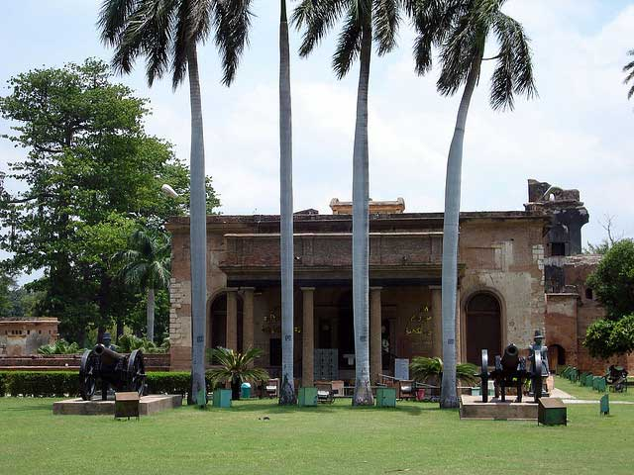*[Photo](https://www.flickr.com/photos/16859321@N05/2246615825" \t "_blank)by Shiv S Tripathi, [CC BY 2.0](https://creativecommons.org/licenses/by/2.0/" \t "_blank)*

Harboring over a 100,000 antiquities the **Lucknow State Museum** is the oldest and the largest museum in the state of Uttar Pradesh. The oldest of antiques date back to the Gupta period along with a vast number of other artifacts, pottery, tools and weapons, manuscripts etc.

**9. Rumi Darwaza**

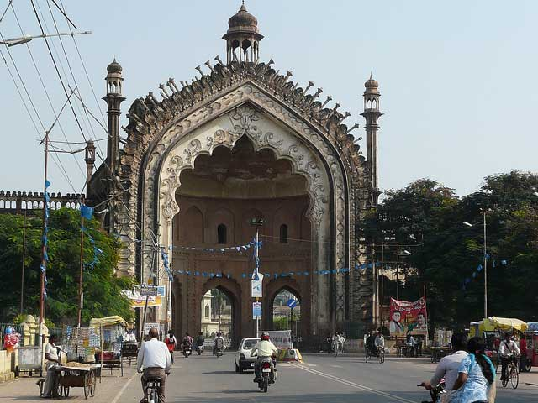*[Photo](https://www.flickr.com/photos/varunshiv/5164472390" \t "_blank) by Varun Shiv Kapur, [CC BY 2.0](https://creativecommons.org/licenses/by/2.0/" \t "_blank)*

Also known by the name, ***Turkish Gate***, the **Rumi Darwaza** was built in 1784 by the Nawab Asaf-ud-daula. The monument is a massive gateway which is one of the best specimens of Awadhi Style architecture. The monument’s grandness in design is often compared to that of Rome and the Ottoman Empire and marks the entrance to the old city of Lucknow.

**10. Chattar Manzil**

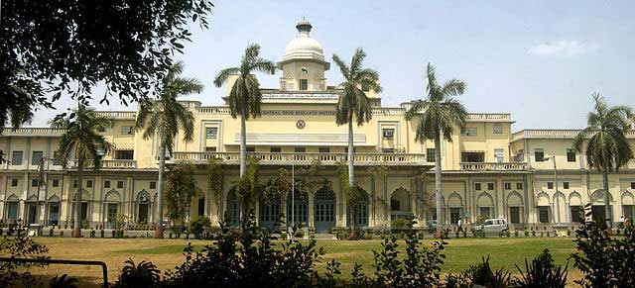*[Photo](https://commons.wikimedia.org/wiki/File:Chattar_Manzil_2005.jpg" \t "_blank) by Harshvardhansonkar, [CC BY-SA 3.0](https://creativecommons.org/licenses/by-sa/3.0/deed.en" \t "_blank)*

The name **Chattar Manzil** literally means the Umbrella Palace and was the residence to the Nawabs of Awadh and their successors. The palace was constructed in the 1780’s and became one of the major strongholds of the revolutionaries during the 1857 uprising. The architectural style of the original building was a cross between Indo-European styles and was later restored by the British according to their preferences.

**11. Begum Hazrat Mahal Park**

*[Photo](https://commons.wikimedia.org/wiki/File:Victoria_Memorial_-_Begum_Hazrat_Mahal_Park.jpg" \t "_blank) by Rini.Chakraborty, [CC BY-SA 3.0](https://creativecommons.org/licenses/by-sa/3.0/deed.en" \t "_blank)*

**Begam Hazrat Mahal Park** was built in 1962 in the memory of the Begum of Awadh, Hazrat Mahal who revolted against the British in the 1857 uprising. The park was renamed to Begum Hazrat Mahal Park and a marble memorial was constructed which bears the Coat of Arms of the Awadh royal family. The park is a major attraction during the major Hindu festivals like Holi and Dussehra.

Lucknow due to its rich cultural heritage and architectural wonders is often described as the BI. The city apart from the above-mentioned **tourist places in Lucknow** are famous for amazing Awadhi cuisine which is a must try for any foodie.

**Here Are Some More Tourist Spots Of Uttar Pradesh:**

* **[Popular Places In Agra](https://www.transindiatravels.com/uttar-pradesh/agra/tourist-places-to-visit-in-agra)**
* **[Popular Places In Lucknow](https://www.transindiatravels.com/uttar-pradesh/kanpur/tourist-places-to-visit-in-kanpur/)**
* **[Popular Places In Kushinagar](https://www.transindiatravels.com/uttar-pradesh/kushinagar/tourist-places-to-visit-in-kushinagar/)**

**About Rohit**

https://www.transindiatravels.com/wp-content/uploads/rohit-author.jpeg

An architect by profession, Rohit Agarwal is a curious traveller, seeking out the minutest detail about the places he travels to, and that’s what one will find in his writings. His writings have appeared in various blogs, he’s currently trying to bring forth as many different places a traveller who shares the same level of curiosity like him would like to visit through his writings.

4 thoughts on “Best 11 Places To Visit In Lucknow”

1. **AKSHAY SINH GOHIL**

I need a tour for Lucknow. Please contact as soon as possible.

[Reply](https://www.transindiatravels.com/uttar-pradesh/lucknow/tourist-places-visit-lucknow/" \l "comment-1093)

1. **Reema mitra**

Very informative!

[Reply](https://www.transindiatravels.com/uttar-pradesh/lucknow/tourist-places-visit-lucknow/" \l "comment-1094)

1. **Sayeed**

Iam very much interested to see all historical places

[Reply](https://www.transindiatravels.com/uttar-pradesh/lucknow/tourist-places-visit-lucknow/" \l "comment-1097)

1. **Mohammed**

I need to see all 11 historical places of Lucknow

Top of Form



Bottom of Form

1. Largest population of india [↑](#endnote-ref-1)
2. srrrtr [↑](#footnote-ref-1)